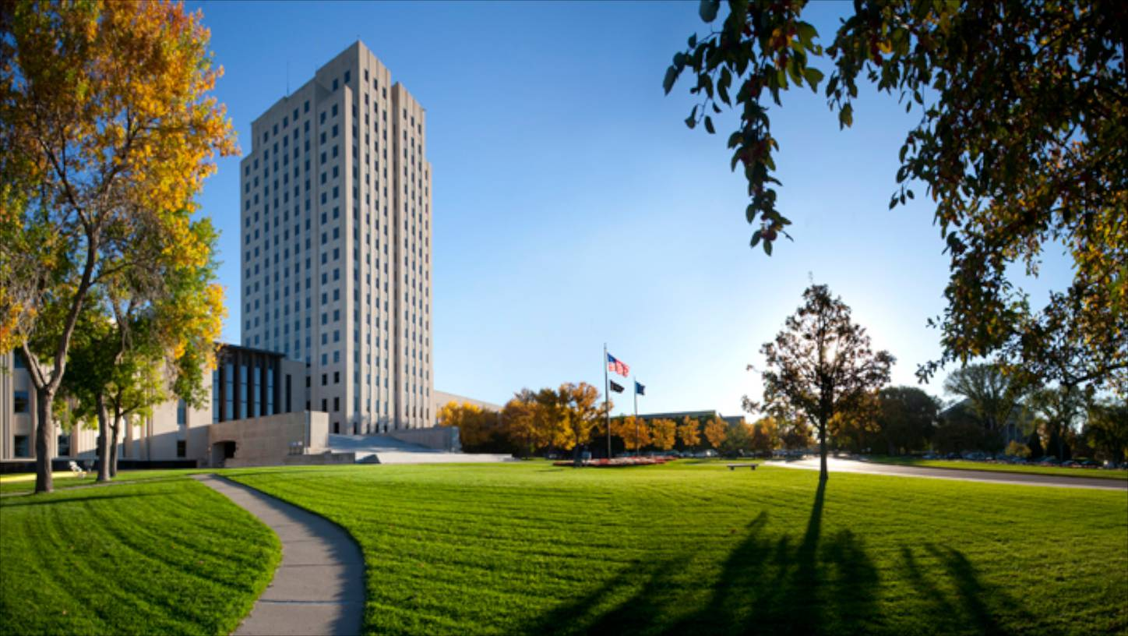
IIANDDDDD
The Power of Partnership
Independent Insurance Agents of North Dakota’s Partners Program is designed to leverage the power of collaboration and relationship-building. Using a flexible tiered approach, our Partner Program allows each company to choose a partner tier and tailor that level to give them the most return for their investment. Each partner level provides companies with year-round exposure to our member agencies and their employees.
IIAND continues to see steady membership growth year over year encompassing over 120 independent insurance agencies and branches across North Dakota with more than 750 employees.
Our members offer all lines of insurance including: property, casualty, life, health, and crop insurance.
IIAND is affiliated on the national level with Independent Insurance Agents and Brokers of America (IIABA) and the Trusted Choice® Brand.

Investing in Our Shared Future
Your IIAND Partnership is an investment in the professional development and strength of our industry. As partners, we can work together to share ideas and resources that benefit North Dakota agencies….join forces to recruit and retain the next generation of independent agents. We invite you to join IIAND in protecting, promoting and growing the independent insurance agency system in North Dakota.
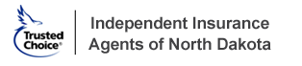

For more information contact Jeff Kleven, Executive Director / jeff@iiand.org / (701) 640-0593
PARTNERS PROGRAM 2022
Benefits at-a-glance
Partner Levels | Diamond  $7,500 | Platinum  $5,000 | Gold  $3,000 | Silver  $1,500 | Bronze  $750
Special Recognition
 | Name | Name | Name | Name | Name
Feature "Partners of the Month” in IIAND Newsletter
List partner sponsorship on IIAND website
Banner Ad on IIAND website with Hyperlink | 2 months | 1 month
Hyperlink to your company website from IIAND website
Free Advertising in IIAND's Newsletter | 1/4 page | 1/6 page | 1/8 page
Recognition as Sponsor of webinars | x
Big I Winter Classic – February 24 & 25, 2022 – Grand Forks, ND
Open mike 2 minutes in front of attendees |  | 
Sponsor Agent of your choice | 3 | 2 | 1
Company Rep Registrations | 2 | 2 | 1
Big I Capitol City Conference – June 8 & 9, 2022 – Bismarck, ND
Open mike 2 minutes in front of attendees
Sponsor Agent of your choice | 3 | 2 | 1
**Golf Team Sponsorship-choose team** | 4 free golf | 2 free golf
**Hole Sponsorship (Pin signage)** | 2 | 1
Sponsor Walking Beer Tour |  |  | 
Speaker/CE sponsor |  | 
Dinner Sponsor | x | x
Company Rep Registrations | 3 | 2 | 1
Farm Seminars
Sponsor Agent of your choice | 3 | 2 | 1
Crop Seminars
Sponsor Agent of your choice | 3 | 2 | 1
Annual Convention – September 7 & 8, 2022 – Fargo, ND
Special recognition at event with speaking time and free advertising in convention publication | Banquet | Opening  Reception
Recognition as Partners at all Convention events |  |  |  |  | 
Free registration for convention | 3 | 2 | 1 | 1
Free Registration for Agent(s) of your choice | 3 | 2 | 1
Team Event Sponsorship-choose team | 4 free | 2 free
Event Sponsorship Signage | 2 | 1
**Benefits can be tailored to optimize your company’s emphasis.

PARTNERS PROGRAM 2022
About your Company
Company Name ____________________________________________________________
Address ___________________________________________________________________
City___________________________ State___________ Zip Code_____________________
Phone __________________________________ Fax ________________________________
Website _____________________________________________________________________
Contact Person
Contact Person ________________________________________________________________
Title _________________________________________________________________________
Phone ___________________________________ Email _______________________________
Additional Contacts
Please provide email addresses of any additional contacts at your company that you would like to receive IIAND’s newsletter and member emails.
Name ___________________________________ Email __________________________________
Name ___________________________________ Email __________________________________
Name ___________________________________ Email __________________________________
Name ___________________________________ Email __________________________________
Independent Insurance Agents of North Dakota,
PO Box 10993, Fargo, ND 58106.
___ Check Enclosed, payable to IIAND
___Invoice me now
___Invoice me after January 1st

For more information contact Jeff Kleven, jeff@iiand.org / (701) 640-0593

Partnership Level and Method of Payment
□ Diamond—$7500
□ Platinum—$5000
□ Gold—$3000
□ Silver—$1500
□ Bronze—$750

